Building a Customer Base for the Long Term
Strategies to develop, implement, and manage a customer experience program in a retail automotive environment designed to build long term relationships and improve retention and satisfaction ratings. (4hours) (minimum attendance (10) required)

The Flat Rate System- Associate Training
Supporting retail automotive service professionals to maximize income opportunities in a Flat
Rate environment. Introduction to the Flat Rate System, Team work in a Flat Rate environment, Why be Flat Rate Technician, Writing your own pay check, and Technical Networking (3 hours) (minimum attendance required)

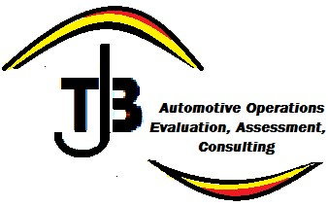
Tire Inspection, Opening the Door to Increased Service & Repair Sales and Profits:

Training Courses and

Seminars:

Producing Professional Inspection results, Tools required for effective Inspection, Wear
Pattern Identification, When to Suggest Tire replacement. Building Tire Related Service Business. Improving Internal Communication Skills. (2 Hours) (Minimum attendance required)

“Plugging the Profit Drain”, Where is all the Profit?
This session is designed to identify where profitability drains may be hidden in your operational process execution. An eye opening experience that will reveal areas of your business that could very well be the draining in your profitability. (90 Minutes),( minimum attendance required)

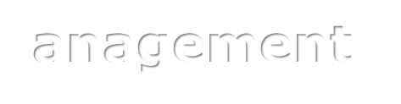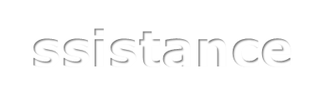
Contact:

T
.

Burke at

maptjb@gmail.com
,
or call (774) 219
-
fo
5558
r
fee,
registration
and

s
cheduling informatio
n
.

